13-1、I2C OLED

1. 参考《0-1》文档，插入ESP32模块。
2. 用导线连接IO口与I2C接口，如下图所示：

红色线<------->SCL

蓝色线<------->SDA

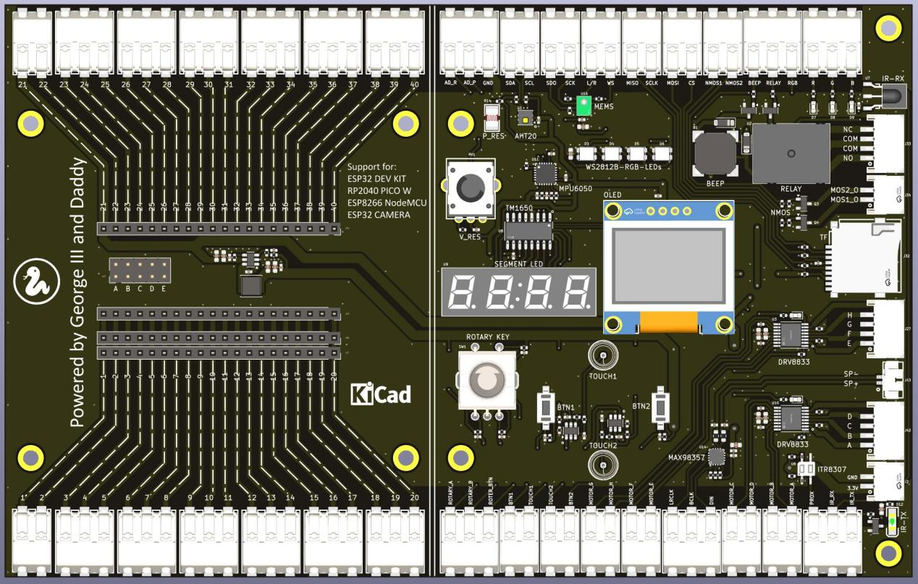

1. 代码示例

#main.py

from machine import RTC,Pin,I2C,Timer

from ssd1306 import SSD1306_I2C

from machine import SoftI2C

import time

def do_oled():

I2C_SCL = 22

I2C_SDA = 21

#i2c = I2C(scl=Pin(I2C_SCL), sda=Pin(I2C_SDA))

i2c = I2C(0, scl = Pin(I2C_SCL), sda = Pin(I2C_SDA), freq = 800_000)

#i2c=SoftI2C(sda = Pin(I2C_SDA), scl = Pin(I2C_SCL), freq=400000)

#print(i2c.scan())

oled = SSD1306_I2C(128, 64, i2c)

oled.fill(0)

oled.text("Hello difiot.com!", 0, 0)

oled.show()

while True:

do_oled()

1. 上传main.py和ssd1306.py文件到模块中，按F5或点击运行按钮，可以看到OLED上显示Hello difiot.com。

